

My Own Strategy:

1. Check your connections for abroad recruiter
2. Filter out the best ones who you think are relevant to you by checking out the company etc
3. For 10 days engage in their posts like likes and comments
4. On 11th day pitch yourself according to the company requirements and do point out if there is a vacancy
5. Also do refer the vacancy position if available
6. Pitch yourself in a way you align yourself for the company’s needs fulfillment and how you can make an impact.
7. Also curate your resume for the pitching appropriately
8. Thus in the end we find out that minimum applying and more personalizing it is the key for success, this is facebook and google strategy to get to the heart of the people.

For pitching you can use this similar framework:



Strategy#1: for getting a good remote job:

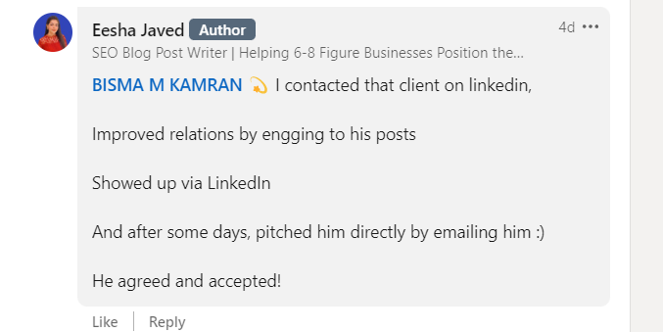

Strategy#2:

1. Check your recruiters’ connections
2. Check the company’s open position via linkedin and their website
3. Check their profiles and write them a message
4. Engage with their posts
5. Cold email them based on the company’s requirements

Strategy#3:

1. Check open positions at motive and amazon
2. Contact Bhai’s for the reference jobs

Strategy#4:

1. Keep calm and solve leetcode problems + give 100% to to your current companies for a good portfolio.